Final Project: Design Thinking

[Methods](https://static1.squarespace.com/static/57c6b79629687fde090a0fdd/t/58890239db29d6cc6c3338f7/1485374014340/METHODCARDS-v3-slim.pdf)

[Sprint (more methods)](https://static1.squarespace.com/static/57c6b79629687fde090a0fdd/t/58d3fa1e20099e1b0371a403/1490287182304/DESIGN+THINKING+PLAYBOOK.pdf)

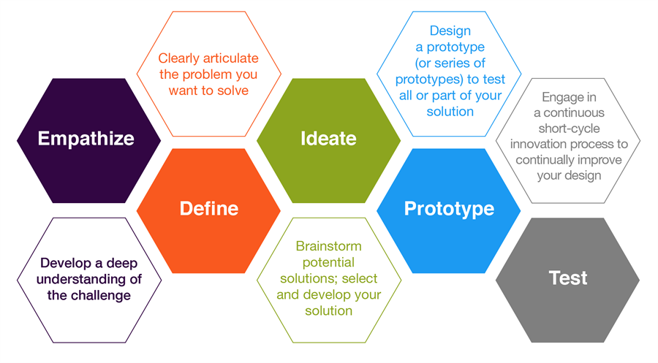

**Step 2: Define**

This step in the process is when you unpack and synthesize your empathy findings into compelling needs and insights and try to **focus** on a specific and meaningful challenge.

**Goals:**

1. Develop a deep understanding of your users and the design space
2. Use that understanding to come up with an *actionable problem statement* and your *unique design vision*

You’re past the observation/interview phase -- you’ve empathized. Now, you have to infer needs from that observation, and leap to insights about your users. This will help you define the problem you’re trying to solve.

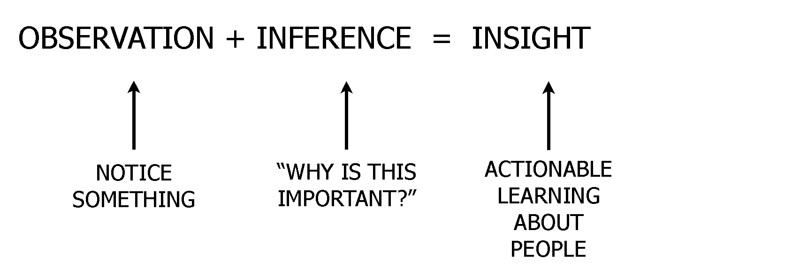

Emphasize below comment about inference:

**Observation:** What you did with your community partners

**Inference:** How can you generalize the information from your interview/observations/etc. to identify the needs, wants, and motivations of the person you’re designing for?

**Insight:** How can you apply design thinking to meet the needs of your person?

**Activity:** Test it out with your interviews/observations!

(Split into project groups)

(5 minutes - if a group had more than one person, have them fill it out as many times as they’d like with different users: 3 minute share)

**WE GOT TO KNOW...**

(a user you were inspired by)

Have the group choose one user they were especially interested in and describe succinctly who the person was.

**WE WERE AMAZED TO REALIZE…**

(a new insight)

Emphasize the fact that this could be extrapolation -- make inferences about the person, their needs, wants, and motivations based on your interview/observations

**IT WOULD BE GAME-CHANGING TO…**

(solve X problem)

Make sure to emphasize that the game-changing thing is defining a problem -- you’re not so much focused on solving it, but rather identifying what could be solved

**Refine: Choose one problem, one meaningful challenge.**

Spend 3-5 minutes discussing the one challenge and problem statement they’re focusing on.

Prompt:

* What from your observations/interviews made you realize this was a problem for your user?
* **Make sure there’s a problem that you’re solving**. (e.g. the person that you’re designing for will consider this a problem)
* ** Note: if you already have ideas, make sure to very clearly define the **problem statement** **